**GOVERNMENT DEGREE COLLEGE, GUMMALAKSHMIPURAM**

**🛡️ EVENT REPORT: Social Media Abuse and Cyber Security Awareness**

**📅 Date:** 22-11-2024   
**🕒 Time:** 11:00 AM onwards  
**🏛️ Venue:** College Seminar Hall  
**🎯 Organized By:** NSS Units I & II  
**👨‍🏫 Guest of Honor:** Dr. T. Sreevaram, Principal  
**👮‍♂️ Chief Resource Person:** SI B. Siva Prasad, Elwinpeta Police Station  
**👩‍🏫 Lecturers Attended:** 10  
**🎓 Students Participated:** 120

**Objective of the Programme:**

To create awareness among students about the **dangers of social media abuse, cyberbullying, and the importance of cyber safety** in the digital era.

**Event Summary:**

The awareness session was conducted under the joint coordination of **NSS Units I & II** at Government Degree College, Gummalakshmipuram. The programme began with a welcome address, followed by a formal inauguration by the **Principal Dr. T. Sreevaram**.

**Key Highlights:**

* **Sub-Inspector B. Siva Prasad** from Elwinpeta Police Station addressed the gathering and delivered an impactful session on:
  + The **increasing incidents of cybercrimes**.
  + How students can protect themselves from **online abuse, identity theft, and scams**.
  + The **legal consequences of cyberbullying** and online harassment.
  + Precautionary steps like **privacy settings, strong passwords, and safe usage of social media** platforms.

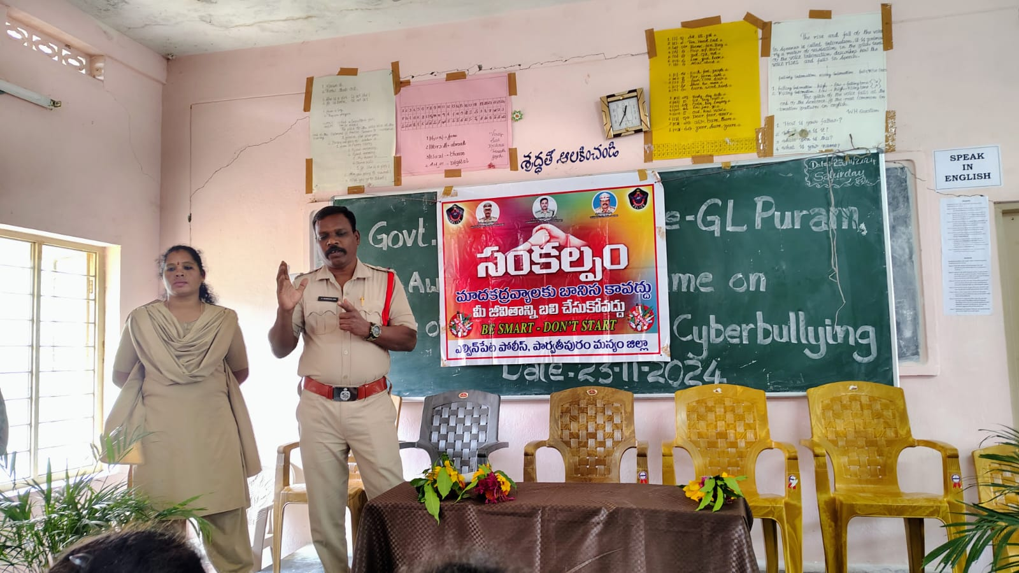

* **Dr. T. Sreevaram**, Principal, emphasized the need for **responsible use of technology**. She spoke about:
  + The **adverse psychological effects** of excessive mobile usage and social media.
  + The importance of maintaining **digital discipline and cyber hygiene**.
  + Encouraged students to report any **cyber threats or bullying** immediately to concerned authorities.

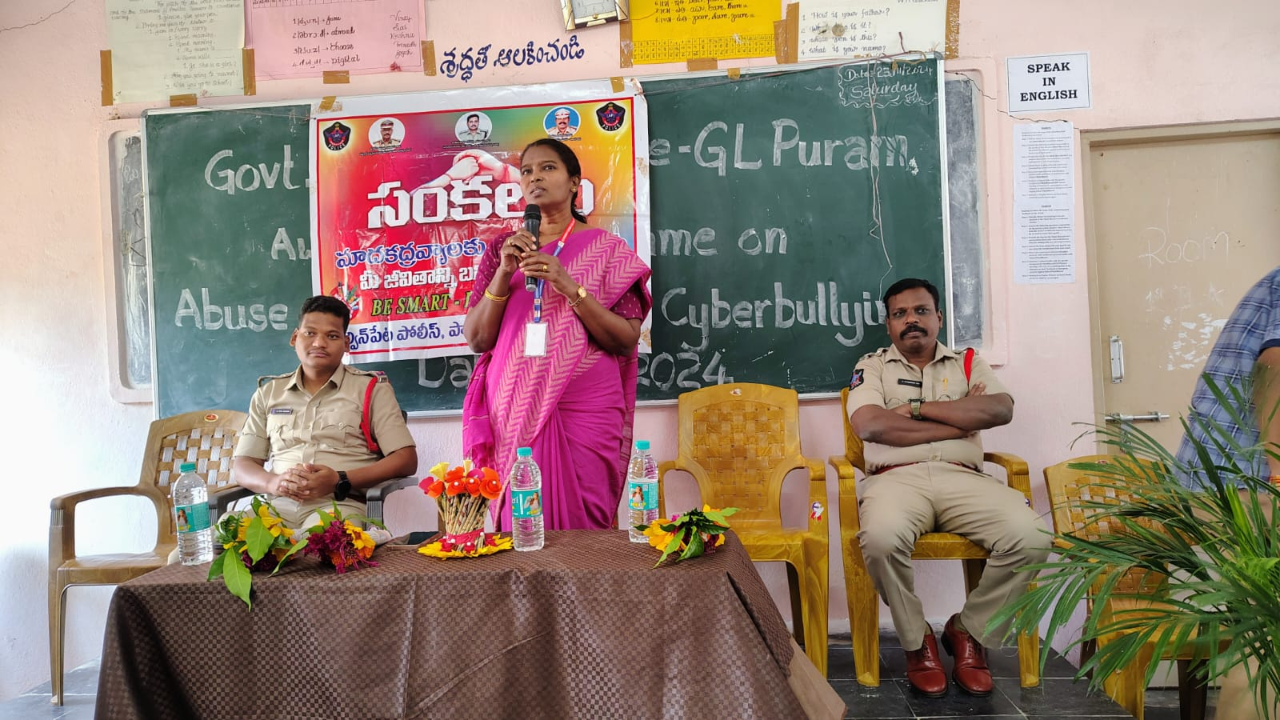

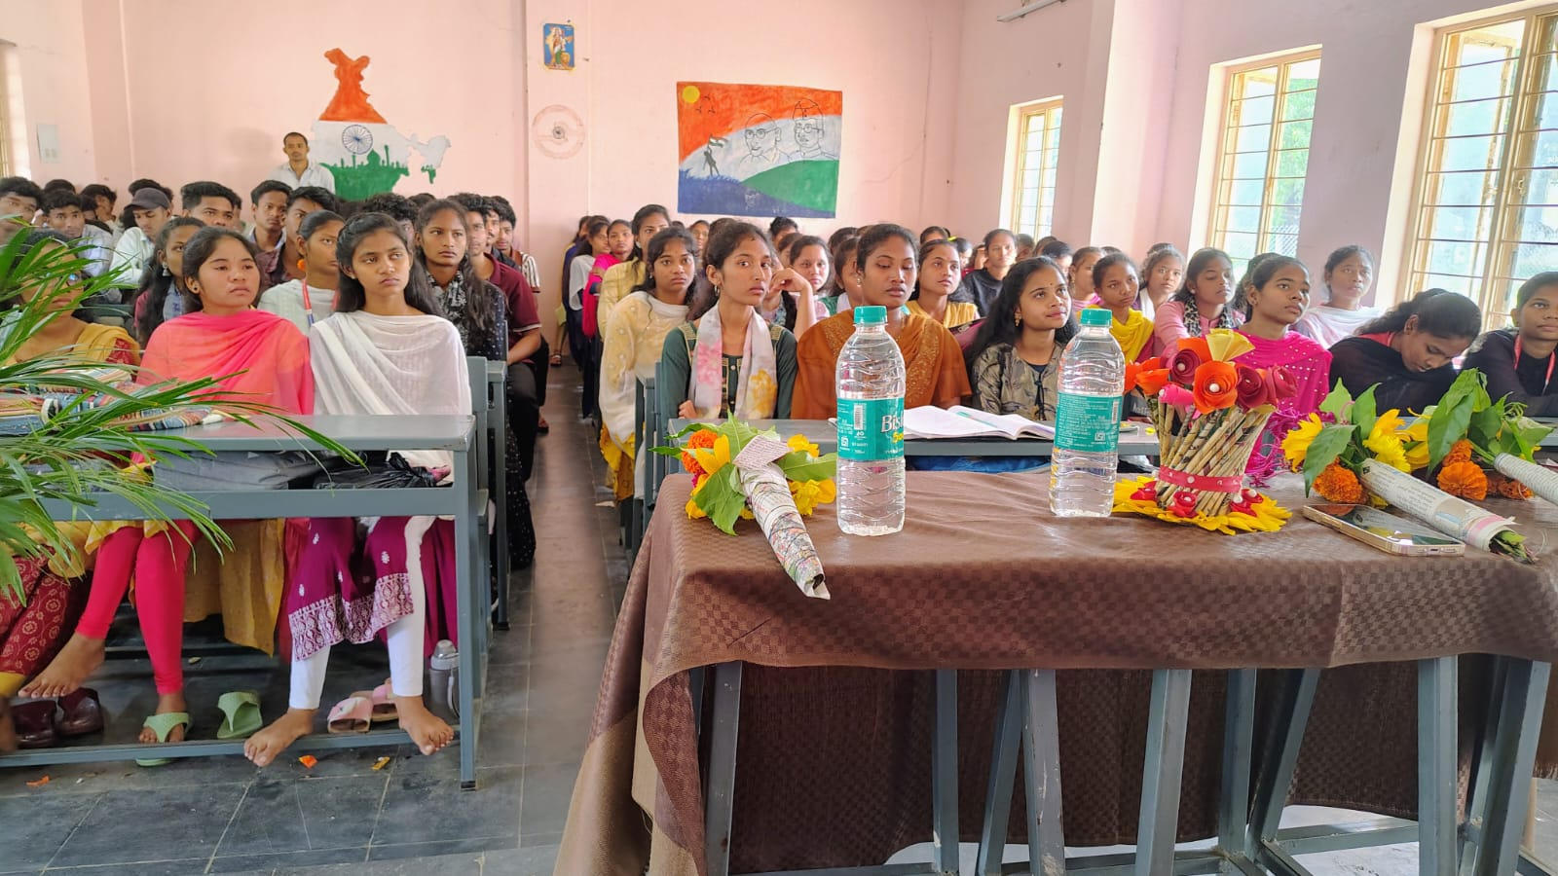

* The session was highly interactive with **real-life examples, Q&A session**, and **live demonstrations** on safe browsing and account protection tips.

### **Outcomes of the Event:**

* Students gained **valuable knowledge** about the hidden risks associated with social media.
* The session helped in **boosting digital awareness and self-protection** in online environments.
* Created a **safe space for discussion**, where students openly spoke about issues they or others have faced online.

### **Conclusion:**

* The **Social Media Abuse and Cyber Security Awareness Programme** was a **timely and much-needed initiative** in today’s digital world. The programme successfully empowered students with the right information to **safeguard themselves from online threats**. NSS Units I & II expressed their gratitude to the guest speaker and the Principal for their constant support and motivation.
* The active participation from students and staff made the event highly successful and informative.